Assignment - 4 (Day 8)

Name : Gowtham J

Email id : [sankargowtham165@gmail.com](mailto:sankargowtham165@gmail.com)

Question

Assignment 0

1. Create a simple shell script to tell the user about their session – they need to know:

● What their username is

● What the current date is

● What the time is

● What their current working directory is

● How many files they have in that directory

● What is the biggest file in their current directory

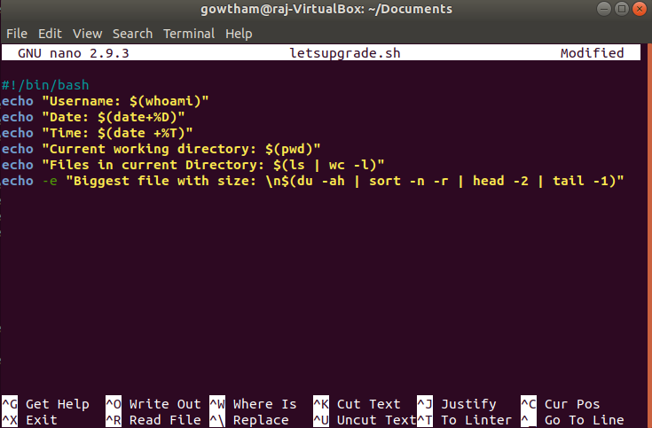

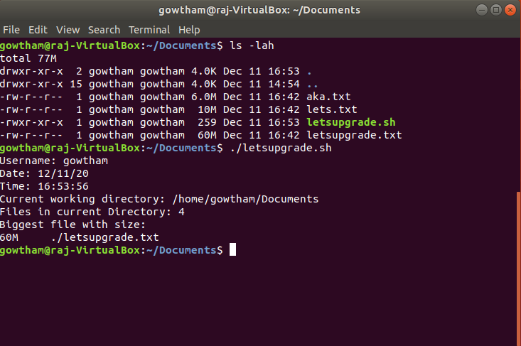

Assignment 1

Create a directory with a few test files in it (the files can be empty). Now write a script that for every file in that directory you rename it to have an extension of today's date in YYYYMMDD format.

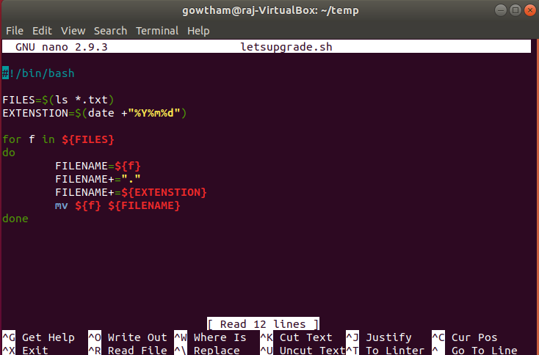

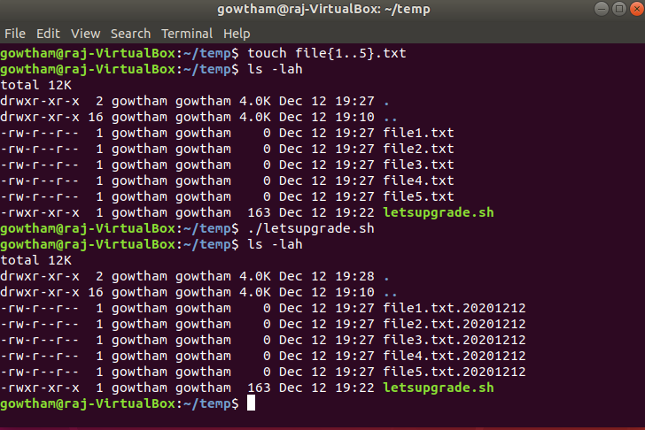

Assignment 2

Write a script that takes a number as an input and reverses it out to the user. For example, if the original number is 74985, the output should be 58947.

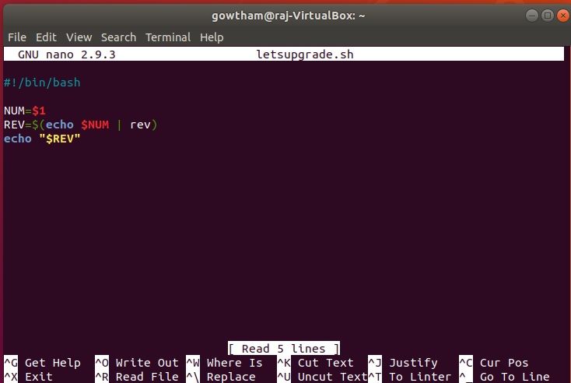

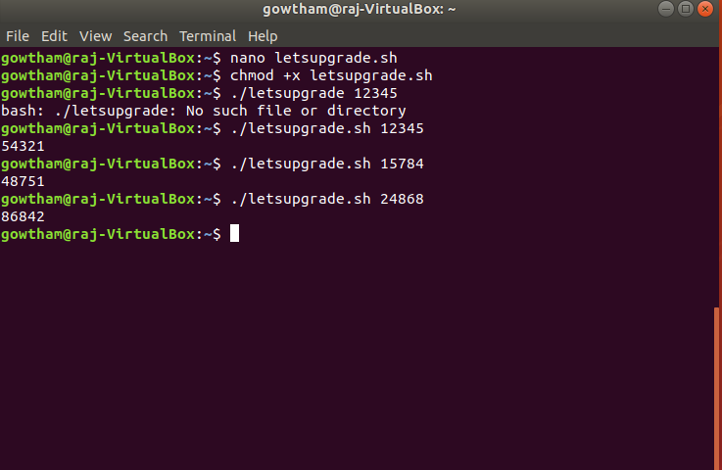

Assignment 3

Write a script to validate how secure someone's password is. Things you would care about:

● Length should be 8 or more characters

● The password should contain numbers and letters

● There should be both uppercase and lowercase letters

